CO3 AT2 Case Study
CSA0603 - Design and analysis of algorithm

Name: M Nivetha
Reg no:192421307

Title
Video Processing System Using Divide and Conquer Matrix Multiplication (Strassen's Algorithm)

Description of the Real-World Problem
Modern video processing applications perform operations such as image enhancement, rotation, scaling, filtering, and color transformation. These operations involve multiplying very large matrices representing video frames. High-resolution videos (HD, 4K, 8K) require millions of calculations, making traditional matrix multiplication slow. An optimized algorithm like Strassen's Algorithm reduces computation time and improves performance.

Problem Statement
Design a video processing system that efficiently performs matrix multiplication for frame transformations. The system should handle high-resolution video frames with reduced computational time by using the Divide and Conquer approach through Strassen's Algorithm.

Algorithm Used
Strassen's Matrix Multiplication Algorithm (Divide and Conquer)
Algorithm Steps
- Divide both matrices into four equal sub-matrices.
- Calculate seven intermediate matrices (M1 to M7).
- Compute the four result matrices (C11, C12, C21, C22).
- Combine the four sub-matrices to obtain the final matrix.
- Repeat recursively until matrices become 1×1.

Justification for Choosing the Algorithm (Why This Algorithm?)
- Faster than traditional matrix multiplication.
- Uses Divide and Conquer technique.
- Reduces the number of multiplications from 8 to 7.
- Suitable for large image and video processing.
- Improves performance for high-resolution video frames.
- Reduces execution time in graphics applications.

Complexity Analysis
Method | Time Complexity
Traditional Matrix Multiplication | O(n³)
Strassen's Algorithm | O(n²·⁸¹) (approximately O(n^2.81))
Space Complexity | O(n²)

Manual Execution (Step-by-Step Process)
Input Matrices
Matrix A
1 | 2
3 | 4
Matrix B
5 | 6
7 | 8
Step 1: Divide the matrices
A is divided into:
A11 = 1 A12 = 2
A21 = 3 A22 = 4
B is divided into:
B11 = 5 B12 = 6
B21 = 7 B22 = 8

Step 2: Calculate Seven Products
M1 = (A11+A22)(B11+B22) = (1+4)(5+8)=65

M2 = (A21+A22)B11 = (3+4)×5=35

M3 = A11(B12−B22)=1×(6−8)=−2

M4 = A22(B21−B11)=4×(7−5)=8

M5 = (A11+A12)B22=(1+2)×8=24

M6 = (A21−A11)(B11+B12)=(3−1)(5+6)=22

M7 = (A12−A22)(B21+B22)=(2−4)(7+8)=−30

Step 3: Compute Result Matrix
C11 = M1 + M4 − M5 + M7 = 19

C12 = M3 + M5 = 22

C21 = M2 + M4 = 43

C22 = M1 − M2 + M3 + M6 = 50

Final Output Matrix
19 | 22
43 | 50

Applications
- Video processing
- Image processing
- Computer graphics
- Artificial Intelligence
- Machine Learning
- Scientific computing
- Medical image analysis
- Animation and gaming

Advantages
- Faster than traditional matrix multiplication.
- Reduces computation time.
- Efficient for large matrices.
- Suitable for high-resolution video processing.
- Improves overall system performance.

Limitations
- More complex to implement.
- Requires additional memory.
- Less efficient for very small matrices.
- Recursive implementation increases overhead.

Comparison with Other Algorithms
Algorithm | Time Complexity | Suitable for Large Data | Divide & Conquer
Traditional Matrix Multiplication | O(n³) | No | No
Strassen's Algorithm | O(n²·⁸¹) | Yes | Yes
Naive Matrix Multiplication | O(n³) | No | No
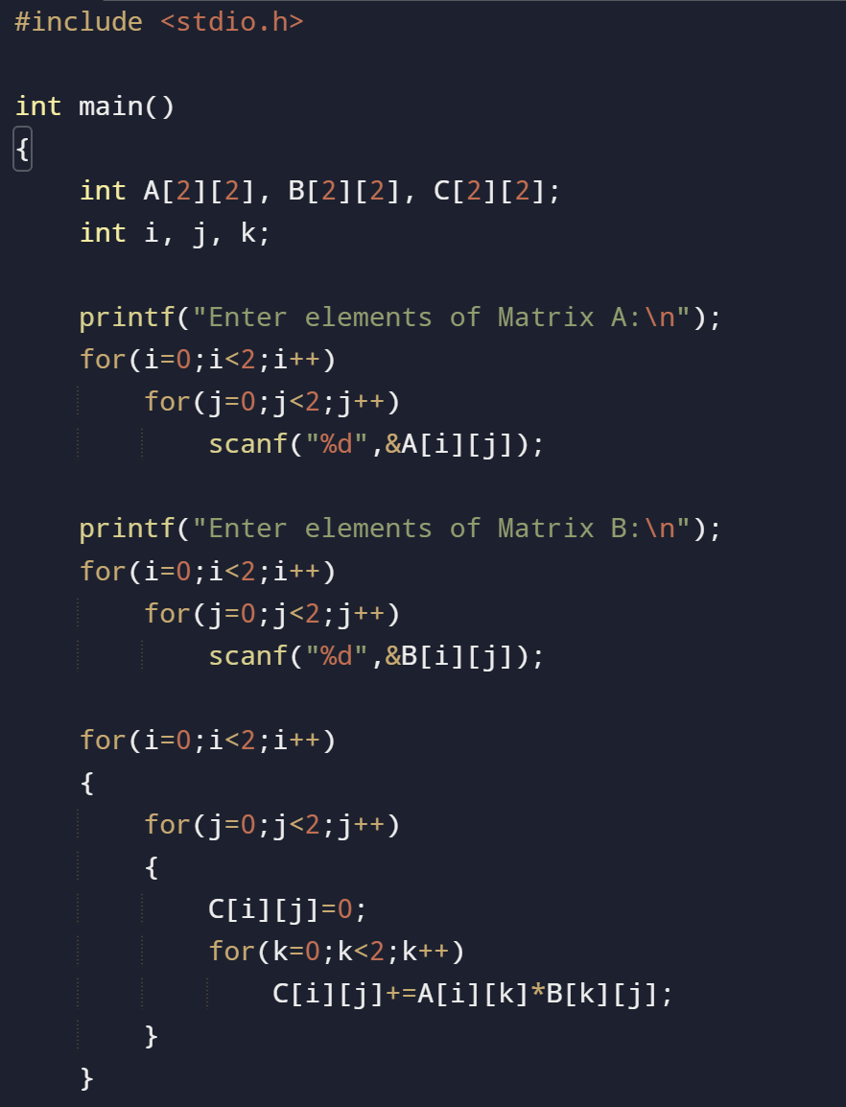
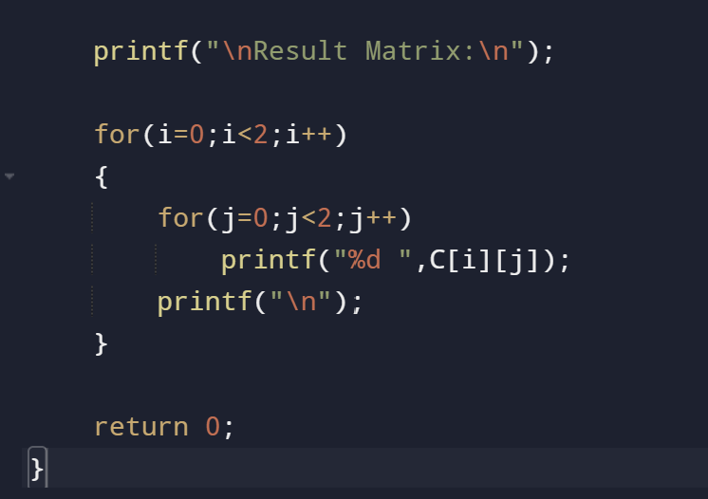
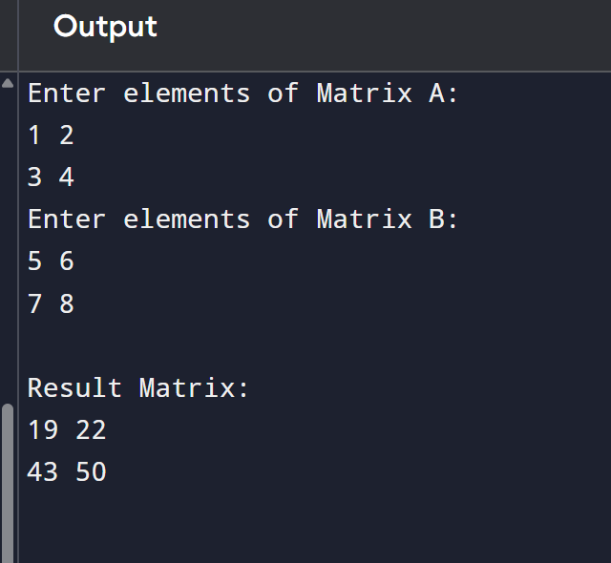

Conclusion
Strassen's Algorithm is an efficient Divide and Conquer method for matrix multiplication in video processing systems. It reduces the number of multiplication operations, resulting in faster execution than the traditional O(n³) approach. This makes it well-suited for high-resolution video processing, image transformations, and real-time graphics applications.

